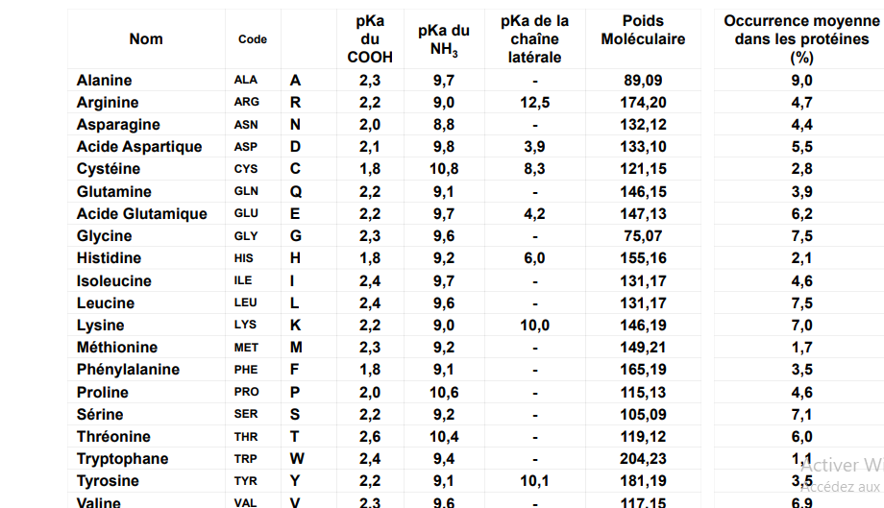

NH₂
COOH
H
R
COOH
CH₂
H₂N
glycine
alanine
H₃C
COOH
CH
NH₂
sérine
COOH
CH
NH₂
HOH₂C
valine
CH
H₃C
H₃C
COOH
CH
NH₂
thréonine
CHOH
H₃C
COOH
CH
NH₂
acide glutamique
HOOC
CH
CH₂
COOH
CH
NH₂
leucine
COOH
CH
NH₂
CH₂
CH
H₃C
H₃C
isoleucine
H₃C
CH
H₃C
H₃C
COOH
CH
NH₂
cystéine
CH₂
HS
COOH
CH
NH₂
méthionine
COOH
CH
NH₂
CH₂
CH₂
H₃C
S
acide aspartique
HOOC
CH₂
COOH
CH
NH₂
asparagine
H₂NOC
CH₂
COOH
CH
NH₂
glutamine
H₂NOC
CH₂
COOH
CH
NH₂
CH₂
lysine
COOH
CH
NH₂
H₂N
CH₂
CH₂
CH₂
CH₂
COOH
CH
NH₂
arginine
NH
CH₂
CH₂
CH₂
NH2
C
NH
phénylalanine
COOH
CH
NH₂
CH₂
tyrosine
COOH
CH
NH₂
CH₂
OH
tryptophane
COOH
CH
NH₂
CH₂
N
H
histidine
COOH
CH
NH₂
CH₂
NH
N
proline
COOH
NH

